./



Version Number:

Team Members :

Team No:

Module: Model Based System Engineering

|  |  |  |  |  |  |
| --- | --- | --- | --- | --- | --- |
| **Ver.Rel. No.** | **Release Date** | **Prepared. By** | **Reviewed By** | **Approved By** | **Remarks/Revision Details** |
|  |  |  |  |  |  |
|  |  |  |  |  |  |
|  |  |  |  |  |  |
|  |  |  |  |  |  |
|  |  |  |  |  |  |

**Document History**

# 

Automatic Traffic light

**INTRODUCTION:**

1. This automatic traffic light helps in changing the light between themselves without man power.

2. And it is budget friendly as well.

3.  This is a twoway traffic light control system with count down timers is to be designed and constructed.

**COMPONENTS REQURIED**:

1 MICROCONTROLLER

2 LED LIGHTS

3 TRAFFIC SIGNAL

4 TIMMER

5 COUNTER

**BLOCK DIAGRAM:**

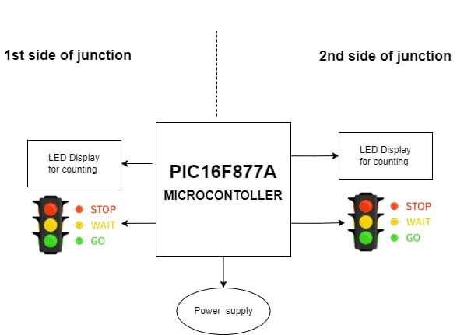

**HIGH LEVEL REQURIMENTS**:

1 MICROCONTROLLER

2 TRAFFIC LIGHTS

3 POWER SUPPLY

**LOW LEVEL REQURIMENTS:**

1 TIMER

2 LED LIGHTS

**WORKING PRINCIPLE:**

* At first two of the traffic lights are with color Red and other is Green.
* Assume the color of traffic signal as (1-Red and 2-Green).
* After 10sec both will turn to Orange.
* Finally, After 5sec first traffic signal changes from Red to Green
* And the second one changes the color from Green to Red.